HONEYPOT

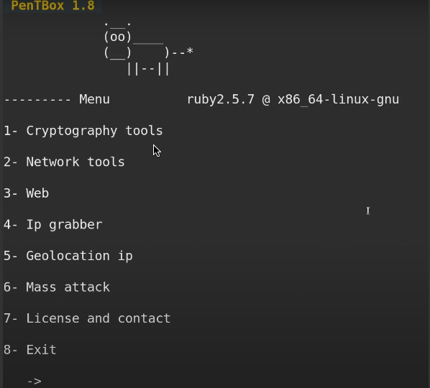

We will be using Pentbox in Kali for this activity. It's important to note that Pentbox is not typically preinstalled in Kali Linux, but installing it was very easy. All you had to do was go to Technicaldata's Github and clone his GIT repo. It was confusing which of the many Pentbox versions and forks the lecture material was referencing, so I went with the most well-liked one, and it worked just fine. We open our app by using a CD, navigate to the location where Pentbox was installed, and execute the script. This is how it looks when we open it.

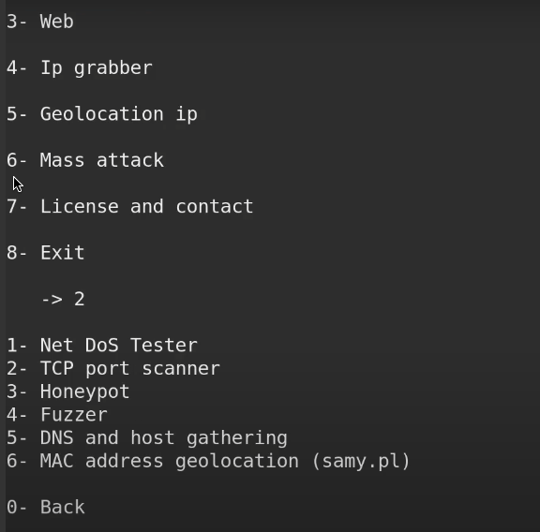

We select number 2

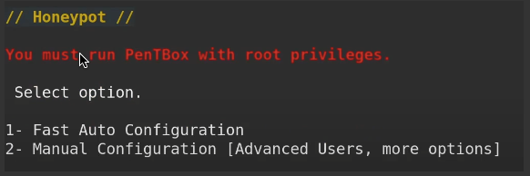

We select option 3 which is honeypot



Here we get a confirmation that it's activated  
after putting my computer's locan IP followed by the port 80 in a web browser we get this:

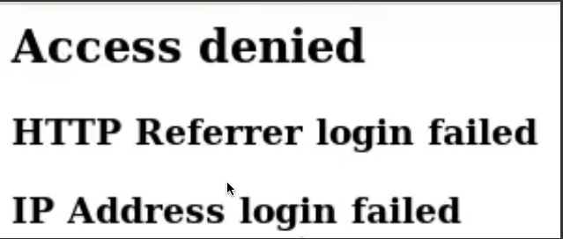

now if we go back to our Terminal we get this:

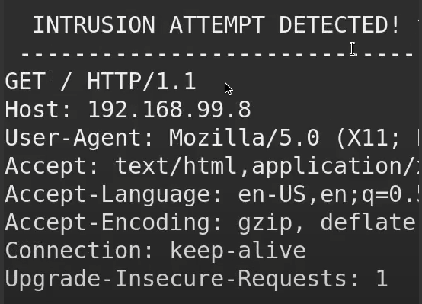

We have successfully created and deployed a honeypot on ourselves. There are a few points I would like to address. First, while I think this is a great idea in theory, there are simpler ways to accomplish this that don't involve using Kali at all. These methods reduce the time and expertise required to create an actual honeypot. The user can also be redirected to a legitimate website, and the website URL can be changed to make it seem more credible. After all, when you use this in the real world, people are less likely to click on 192.168.1.0:80 than on a link that says cutepuppies.com. This is how it works on the home page.

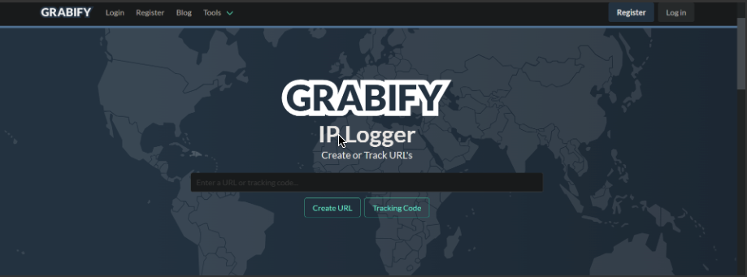

We will just add any website we wish the target to be sent to after we grab their details, i'll use www.emu.edu.tr, then it asks you to customize the URL.

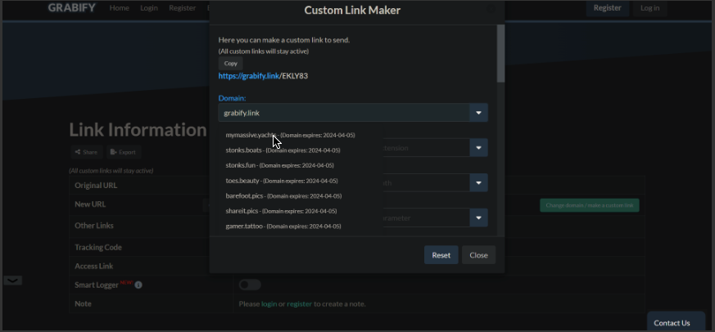

We can change the extention to make it even more realistic

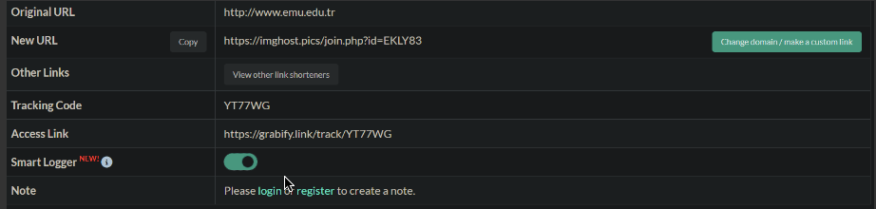

Any target is more likely to click on https://imghost.pics/join.php?id=EKLY83, as I mentioned earlier. In comparison to a random IP address, it is also quite simple to set up, taking less than a minute. This is how the website displays the information of the person who clicked on your link.

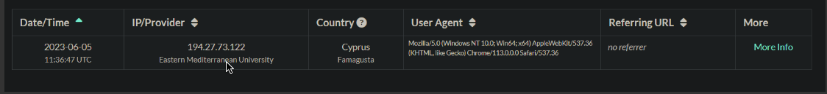

I hope you enjoyed my experiment! Exactly the same results, possibly even better, more realistic for the target as they will be sent to a genuine website, and half the hassle for the one setting the trap!